5. The online flight reservation system enables users to search for flights by destination, date, and class, displaying available options with real-time seat availability. Users can register, log in, and manage their reservations via a personal dashboard. The booking process includes selecting flights, choosing seats, entering passenger details, and making secure payments through an integrated payment gateway. Admins can manage flight schedules, seat inventory, and user accounts using an advanced admin panel.
Aim:
To develop a responsive web-based flight reservation system that lets users search flights, book seats, pay, and view, print or cancel tickets, and lets admins manage flights, users and reports.
Code:
<!DOCTYPE html>
<html lang="en">
<head>
<meta charset="UTF-8">
<meta name="viewport" content="width=device-width, initial-scale=1">
<title>Flight Reservation System</title>
<style>
body { font: 16px Arial, sans-serif; max-width: 700px; margin: 35px auto; padding: 20px; color: #222; }
section { border: 1px solid #ddd; border-radius: 8px; padding: 18px; margin: 16px 0; }
input, select, button { padding: 9px; margin: 5px 2px; }
button { cursor: pointer; }
</style>
</head>
<body>
<h1>Flight Reservation System</h1>

<section>
<h2>Search Flights</h2>
<form id="flightForm">
<input id="from" placeholder="From" required>
<input id="to" placeholder="Destination" required>
<input id="date" type="date" required>
<select id="class">
<option>Economy</option>
<option>Business</option>
<option>First Class</option>
</select>
<button type="submit">Search</button>
</form>
<p id="flightResult"></p>
</section>
<section>
<h2>Book Ticket</h2>
<input id="passenger" placeholder="Passenger name">
<button onclick="bookFlight()">Book Sample Flight</button>
<p id="ticket"></p>
<button onclick="window.print()">Print Ticket</button>
</section>
<section>
<h2>View Booking Status</h2>
<input id="bookingId" placeholder="Enter booking ID">
<button onclick="checkStatus()">Check Status</button>
<p id="status"></p>
</section>
<script>
let currentBooking = "";
document.getElementById("flightForm").addEventListener("submit", function(event) {
event.preventDefault();
const from = document.getElementById("from").value;
const to = document.getElementById("to").value;
const date = document.getElementById("date").value;
const flightClass = document.getElementById("class").value;
document.getElementById("flightResult").textContent =
`Sample flight: ${from} to ${to} | ${date} | ${flightClass} | Seats available: 12`;
});
function bookFlight() {
const name = document.getElementById("passenger").value.trim();
if (!name) {
document.getElementById("ticket").textContent = "Enter passenger name first.";
return;
}
currentBooking = "FL" + Math.floor(100000 + Math.random() * 900000);
document.getElementById("ticket").textContent =
`Ticket confirmed for ${name}. Booking ID: ${currentBooking}`;
}
function checkStatus() {
const id = document.getElementById("bookingId").value.trim();
document.getElementById("status").textContent =
id && id === currentBooking ? "Booking confirmed." : "Booking not found.";
}
</script>
</body>
</html>
OUTPUT
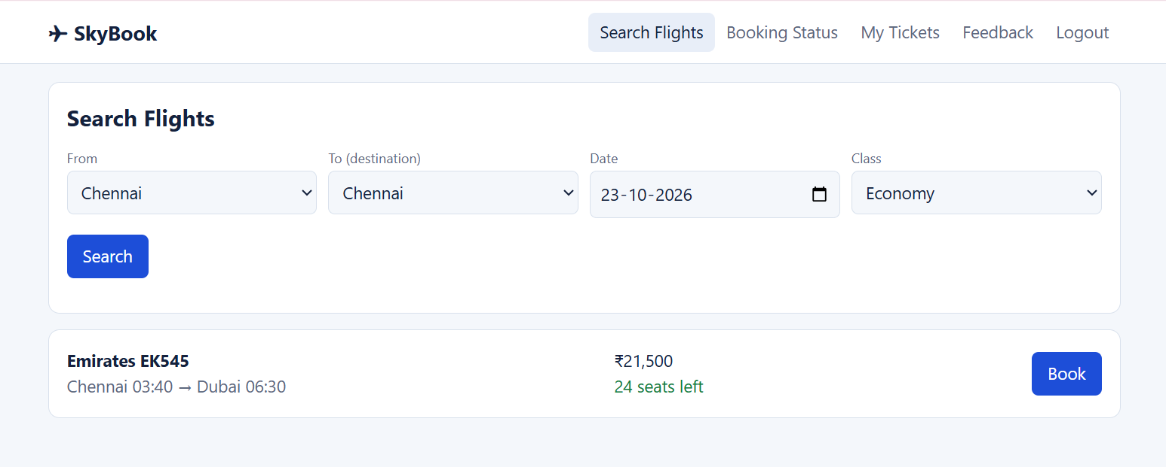
RESULT
The Flight Reservation System webpage was created successfully. It supports sample flight search, ticket booking, booking status lookup, and ticket printing.

